EXPANDING AND FACTORISING QUADRATICS
Pearson Edexcel - Thursday 8 November 2018 - Paper 2 (Calculator) Foundation Tier

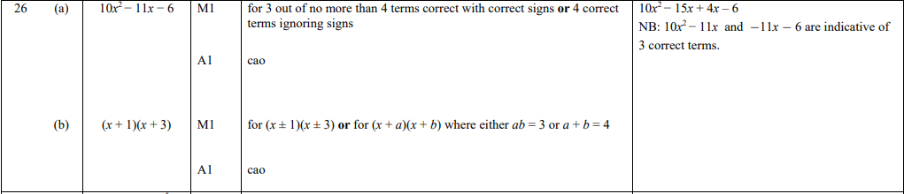

Pearson Edexcel - Monday 6 November 2017 - Paper 2 (Calculator) Foundation Tier

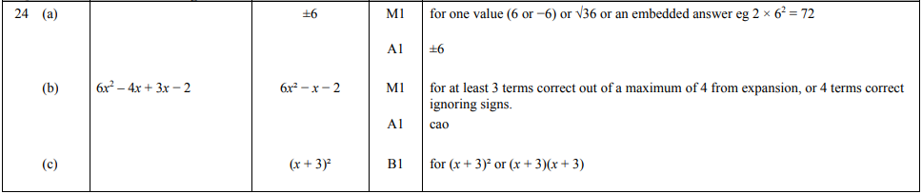

Pearson Edexcel – Specimen 1 - Paper 3 (Calculator) Foundation Tier

OCR Thursday 07 November 2019- Morning (Non-Calculator) Foundation Tier
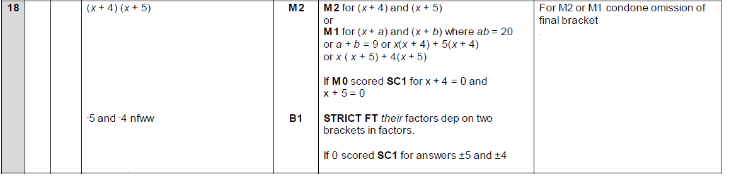

OCR Thursday 8 November 2018 – Morning (Non-Calculator) Foundation Tier
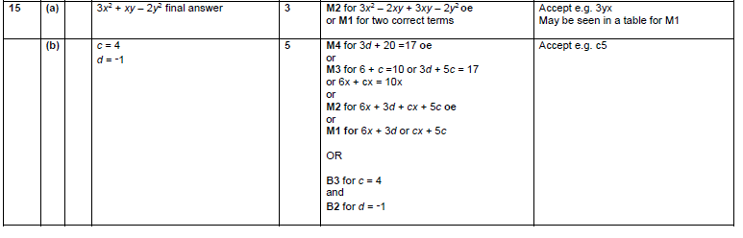
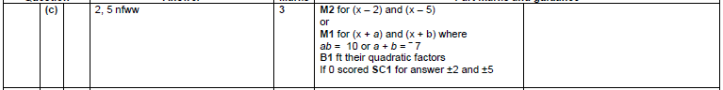

OCR Thursday 7 June 2018 – Morning (Non Calculator) Foundation Tier
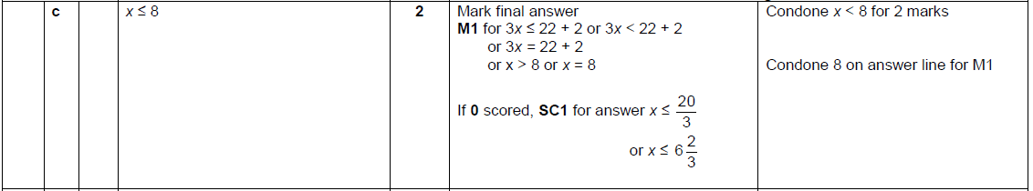
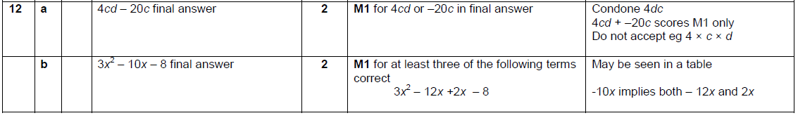

OCR Monday 6 November 2017– Morning (Calculator) Foundation Tier
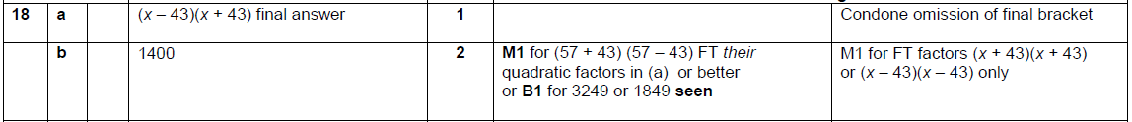

AQA Wednesday 8 November 2017 – Morning (Calculator) Foundation Tier

